Prototypes:  
int32_t StartVeriStandGateway(void *ServerCmdRef);  
int32_t StopVeriStandGateway(void *ServerCmdRef);

The open call **does not block** until completion, so you have to call the open and then make your own wait for it to complete. An example implementation would be like below, but put in an open workspace reference call inside the loop. Once that call succeeds… you can treat the gateway as up-and-running for you to do whatever.

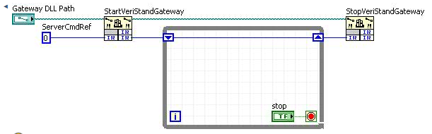

The gateway DLL is in <Program Files>\National Instruments\VeriStand 20xx\data

**BIG NOTE #1:** Gateway dll tries to load the other dlls by relative paths and it doesn’t work right unless the VI that launches it is executing from the <Program Files>\National Instruments\VeriStand 20xx directory.

**BIG NOTE #2:** The gateway dll is a labview built DLL. A labview built DLL cannot be called from LabVIEW inside the UI thread or labview will hang. This is a known labview issue. Since there is no option on the call library function node (CLFN) to say “run in not-UI thread”, you must work around this by wrapping the CLFNs inside a subVI that has its execution thread option set to “standard”.

**There is a helper program in this same dir to do all of this by UDP commands. You can build this into an EXE and place it in the <Program Files>\National Instruments\VeriStand 20xx directory and then launch that exe programmatically, and send it commands for it to launch/stop the gateway.**